START everyone; FM synth sound 1; quick, abrupt gestures

CUE 1 one player; recorded sound; circular gestures

CUE 2 +player; FM synth sound 1; short bursts of movement

CUE 3 +player; recorded sound; slow linear movement

CUE 4 increase activity and movement;
+player(s) that left; FM synth sound 2; slow linear gestures

CUE 5 -all players with synths, one by one

CUE 6 -rest of the players

CUE 7 +player (1-3); shifter; striking gestures

CUE 8 shifter: slow linear movements.
+player (1-3); synth sound 1; quick, abrupt gestures

CUE 9 -all players with shifter, one by one

CUE 10 synth: sound 4; very slow, almost no movement

CUE 11 +player (1-3); recorded sound; hectic and frantic gestures

CUE 12 +rest of the players; synth sound 2; quick, abrupt gestures

CUE 13 players with recoded sounds (cue 11): very slow, almost no movement

CUE 14 -all players with synths, one by one

CUE 15 +player (1-3); shifter; linear gestures

CUE 16 increase activity

CUE 17 +rest of the players; synth; circular movement
all very active

CUE 18 decrease activity, gestures get slower

CUE 19 -all players with recoded sounds, one by one

CUE 20 -all players with synths, one by one.

CUE 21 one players; shifter; very slow, almost no movement

END all sound off

FARBENKLANGSPIEL

For any number of laptops, with one person conducting.

The MAX/MSP patch used by the laptops has a sound component and a video component.
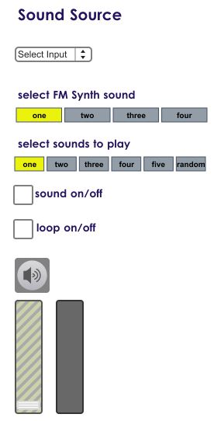
Performers can play sounds from 3 different inputs:
FM synth, pre-recoded sound files, and pitch shifter (processing the same sound files)

FM synth has four pre-programmed sounds, but it also allows the performer have control over the synthesized sound. Click “Show FM Synth” to bring it up.
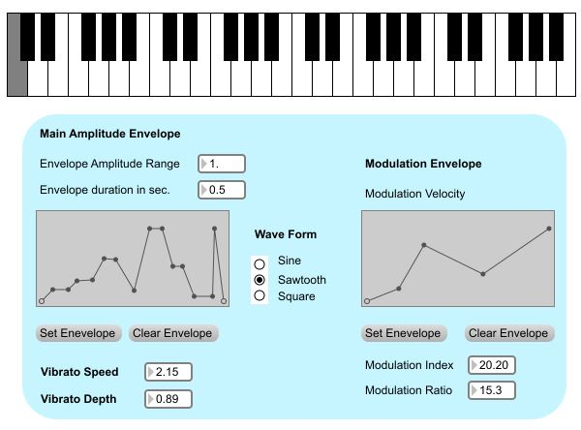
During the performance, pitches of the synthesized sound are controlled by the video color tracking.

The five pre-recoded sounds cannot be modified, but are processed by using video color tracking.
In this case, it controls playback speed, and Pitch Shifter's pitch, delay, and feedback.

To activate color tracking, click on the desired color to track in the picture on the left (showing the video input.)
The picture on the right shows a processed video input, highlighting the tracked color.
Color tracking works best with bright colors, glow sticks, LEDs, or infra red.

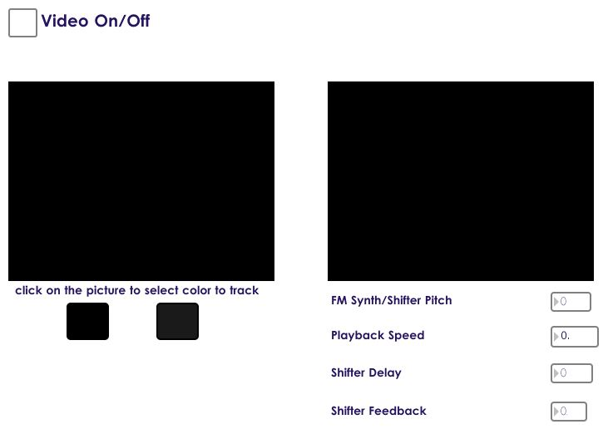
Generally, performers can choose what sounds to play, unless a specific one is indicated by the conductor.

For the conductor:

The conductor uses a text score with cues to the performers.

+/- adding/taking out performers.

Sound input can be indicated by a number with the right hand: 1 = FM synth 2 = recorded sound 3 = shifter

Specific sound can be indicated by a number with the left hand.

The conductor can show the movement or gesture, to be imitated by the performers.

Ensembles are welcome to come up with any other methods.

The duration of the piece is indeterminate.
However, cues should be 5-20 seconds long. Timing the cues is open for the decision of the conductor/ensemble.
A timer MAX/MSP patch is available.

